1. 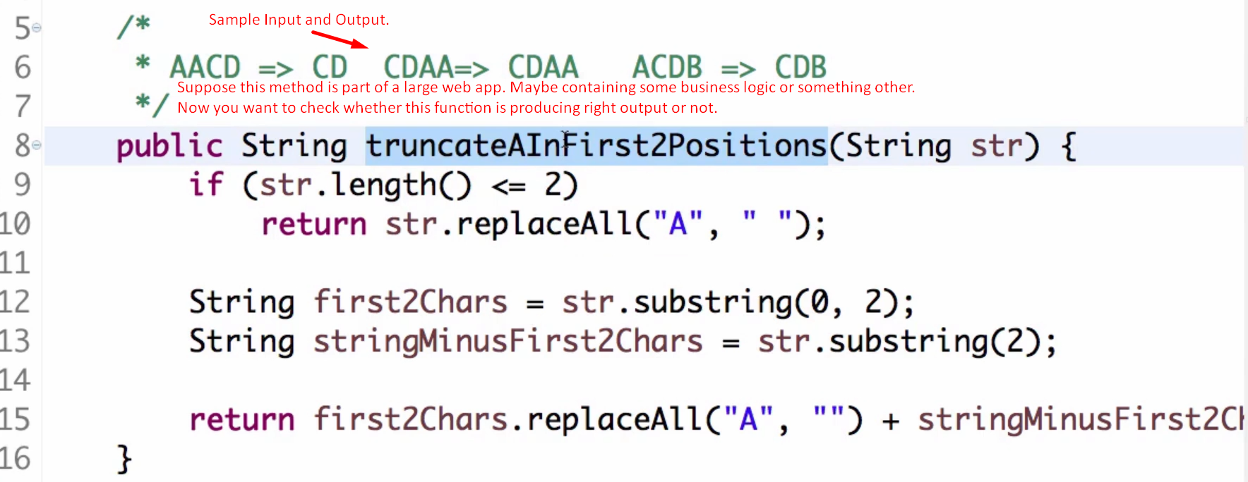
2. Let’s check this function. (Assuming on a particular web screen, this method is being called).
3. **The traditional Approach**:
   1. We will build the war, deploy it to a web server. And then navigate to this particular screen and check whether proper output is coming or not.
   2. Now, suppose, we make a small change in the function logic. In line# 10 now 🡺 (“A”, “”);
   3. Now again, we have to repeat all the steps in (a).
   4. **Solution**: Unit Testing. It tries to address this problem.
4. **Unit Testing**:
   1. When we try to write business logic in a method (called unit), we try to test the unit only instead of deploying the whole app (having all units).
   2. **Unit**: A unit can be
      1. A method.
      2. A set of methods.
      3. A set of classes.
      4. In typical case. a unit is a method or set of methods
5. **Advantages**:
   1. Once we write unit tests, within milliseconds, we can check whether the method is producing right outputs or not.  
      So, we don’t need to deploy the whole app.